**Blockchain**

A blockchain is a growing list of records, called blocks, which are linked using cryptography. Each block contains a cryptographic hash of the previous block, a timestamp, and transaction data.

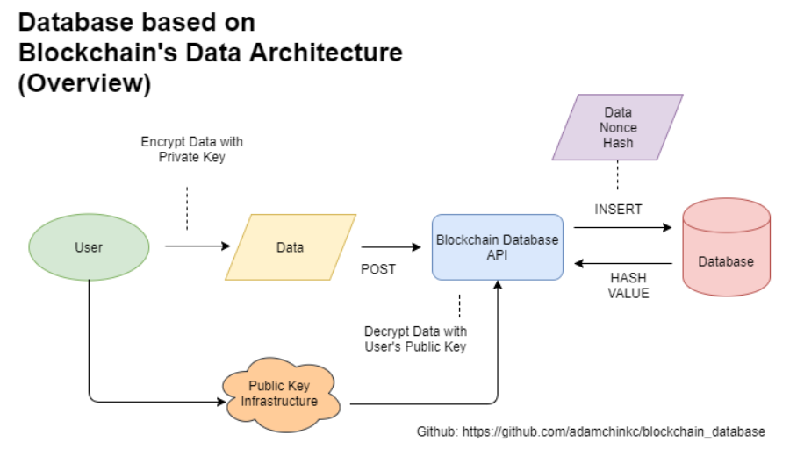

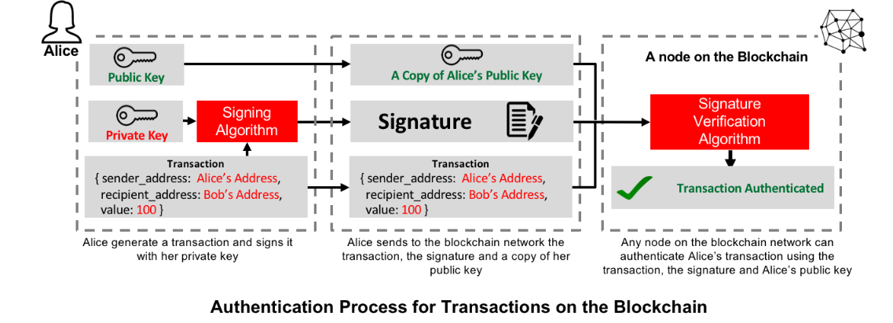

**Blockchain terms:**

* Encryption
* Cryptocoin or cryptocurrency
* Bitcoin
* Ethereum
* Miners and digital mining
* Nodes
* Token
* Hash
* ICOs
* Forks

**1. Encryption**

In the IT world, encrypting information consists of hiding it in such a way that it can only be interpreted if the user has a password or code. In cryptography, ciphering has the same purpose. It’s a technique that allows users to protect the exchange of data and in which the processes in which they are used are more secure.

**2. Cryptocoin or cryptocurrency**

Just like cash money, crytocurrency is a means of exchange, but in this case, a digital one. The first cryptocurrency to begin operating was bitcoin, in 2009, after Satoshi Nakamoto established the basis of the system (eight years after, though, it´s still not 100% clear who created the currency). From that time on, other crytpcurrencies have appeared, with different specifications and characteristics. Today, there are more than 1,000 in the market, of all kinds.

**3. Bitcoin**

Bitcoin is a decentralized currency, meaning it is not supervised by any authority or institution. It is not controlled by anyone in particular; that’s why it´s said that everyone who participates in the system controls it – and, at the same time, no one does. Bitcoin is an open code and is identified through ciphered and anonymous codes (instead of bills and coins). It allows all kinds of financial transactions to be registered easily, in a secure environment among equals, since it uses peer-to-peer (P2P) technology.

Blockchain was first created as a core component of bitcoin which made it the first digital currency to solve the double spending problem without the need of a trusted authority or central server. Bitcoin’s value doesn´t cease to amaze: as of November 2017, a bitcoin is valued at more than $7,100.

More and more suppliers are accepting bitcoin as a form of payment. Already, all kinds of products and services can be bought with the cryptocurrency. For example, Microsoft allows customers to use bitcoin to buy apps, games or videos in Windows, Windows Phone and Xbox; in Overstock, customers can purchase jewels, furniture and home appliances; at Showroomprive, a European retail company, clients can buy cosmetics, accessories or clothes, just as they can in many more physical and online stores. Nevertheless, due to the steady increase in its price during the last months, its use as a means of payment has decreased.

Also, the word Bitcoin (with a capital B) is used to refer to the protocol that uses blockchain and to the P2P network that underpins it.

**4. Ethereum**

Ethereum is a decentralized platform that enables the creation of “smart contracts”; some have dubbed it a “decentralized supercomputer.” It also operates on its own blockchain and was orginally conceived as an improved version, to surpass the programming limits of Bitcoin. It codifies data in the same way, but one of the principal differences is that is can be used to execute smart contracts (pieces of software that automate and shield the execution of previously programmed orders) and has a large variety of applications beyond those related to the field of finance. Its cryptocurrency is Ether, the second most used after Bitcoin; as of mid-October, it was valued at $338.

**5. Miners and digital mining**

Mining is the process through which new bitcoins are launched onto the market, according to the timing set by Nakamoto in his protocol, through the creation of “chained blocks.” The people who are in charge of doing this are “miners”; they work with powerful computers connected 24 hours a day, making sure that all the transaction are performed correctly. To validate each transaction and create the blocks, the miners must find the “hash” or digital key, for each block, in order to link it with the next one. Each time one of the miners finds one of these crytographic keys a bitcoin is “mined” and they receive payment in this same currency.

**6. Nodes**

The nodes are the computers that form part of the blockchain network. They are charged with storing and distributing, in real time, the updated copies of the transactions that are carried out. Each time a new block is generated and added to the general ledger, a copy is also added to all the nodes in the network. All the miners are nodes, but not all the nodes are miners.

**7. Token**

Traditionally, “token” was the name given to chips acquired with money that were used to purchase goods or services; for example, to gamble in a casino or to buy food at a fair. In the blockchain world, this word means the same, but in the virtual sense: tokens are units of value that can be acquired through blockchain, and are also used to acquire goods and services.

Just like Bitcoin, these units are transferred through messages on the blockchain network but the difference is that they can be exchanged for all kinds of services. They can even be used as a guarantee of the reception of future services that a company promises to offer, when they are used in ICOs (Initial Coin Offerings) as a way to finance startups.

**8. Hash**

The groups of blocks which the blockchain miners are charged with must be validated by the system. To do this, the miners must find a password or digital fingerprint that identifies them. This password is called a hash. It is unique, unrepeatable and cannot be modified. Besides, each time a new hash is discovered, it is distributed to the rest of the nodes in the network, so that they are always sychronized.

As software engineer Tess Rinearson says in this article, “Gold gets its value by being a precious metal, and a winning hash gets its value by being a precious number.”

**9. ICOs**

ICOs, or Initial Coin Offerings, are a form of company financing. The peculiarity is that the companies offer tokens instead of shares and the shareholders pay with digital coins, through blockchain. However, given the lack of regulation of this kind of financing, at times these “tokens” don’t represent shares or real economic rights over the company that issues the ICO.

**10. Forks**

The strength of the public blockchain networks lies in their 100% democratic nature. Everything is decentralized and all parties have the same information; no one individual is above another. But, as Luis Garicano, professor at the London School of Economics, explained during the recent South Summit in Madrid, that strength harbors an implied weakness. “If everything is decentralized and everyone has to agree with the changes, you won´t be able to change anything, improve anything. And if you centralize in part in order to make changes, you are attacking the very nature of blockchain.”hat paradox has as its consequence the so-called forks. When one part of the network users wants to make changes and they encounter the opposition of others, the resulting impossibility of finding unanimous positions produces forks in the blockchain networks.

Bitcoin itself experienced a fork last August 1, after an argument about the size of the blocks in its blockchain, which gave rise to Bitcoin Cash (BCC). Another well known fork is the one that occurred in ethereum in 2016. At that time, a hacker attack showed up a programming error that caused a split of the network into ethereum and ethereum classic. Recently, ethereum has updated its code, through a fork – this time, a planned one aimed at making an overall improvement in the platform. This is the first phase of a larger update that will include changes to increase efficiency.